Introduction
Effective from the 5th October 2021 the new Deferred Sales Model for Add On Insurance Obligations (DSM) come into force. The change has been brought about by the findings of the Hayne Royal Commission into the Financial Services industry.
The Commission identified numerous cases where clients were being sold financial products at the same time as buying other goods and services where the financial products were either inappropriate to the needs or requirements of the client or provided minimal economic value to the client. It was also found that in many cases clients were subject to unfair sales practices and believed that the purchase of the financial product was a mandatory part of purchasing the related goods and services.
Examples of such behaviour and products included Tyre and Rim Insurance and Consumer Credit sold via Motor vehicle dealerships.
Based on these findings the government has passed legislation to break the perceived nexus between purchasing the goods and services and purchasing the related insurance referred to as Add On Insurance.
It must be said that there were no instances raised in the Royal Commission of general insurance brokers directly involved in the inappropriate sales of add on insurance, however the new obligations apply to brokers regardless of this.
Effectively Add On Insurance, except where an exemption applies, cannot be sold to a “Consumer” at the same time as the “Principal Service or Product”. There is a pre deferral period and a mandatory 4 day post sale deferral period that applies. This means that the financial product cannot be sold to the client until 4 clear days after the client commits to purchasing the “Principal Service or Product” and the client has been provided with a “Customer Information Sheet”.
The “pre deferral period” covers the period from when the client intends to purchase the “Principal Service or Product” and when the client commits to the purchase.

Scope of the DSM
The ASIC Act and ASIC’s RG275 guidance paper attempt to ban all of the scenarios that unscrupulous sales people may engage into get around the deferral periods. For example:
- If you refer a client to a third party, the third party cannot make contact with the client until 4 days post sale.
- You cannot present the insurance as complimentary but take the clients credit card details or other information prior to the end of the 4 day deferment period and then automatically trigger coverage at a later date.

Additional Consumer Protections
The client can opt out of being provided with any information or sales material relating to the insurance as well as opting out of any contact by any means in relation to the sale of the insurance. Once the client opts out, there can be no contact with the client.
The client can return the financial product within 6 weeks of purchase with a full refund (less any claims paid) where the product was sold within the deferment period. The seller will also be subject to potential penalties and fines in such cases.

Exemptions
The DSM does not apply in the following situations:
- The purchase of the Principal Service or Product is used in a business and the cost of the insurance exceeds $1,000.
- The insurance sale is being provided via a Personal Advice model and the Principal Service or Product is also supplied by the financial adviser/insurance broker.
- Where ASIC have specifically granted an exemption to a product in addition to the list below.
- Specific Financial Product Exclusions
  - comprehensive motor vehicle or vessel insurance products;
  - compulsory third party motor vehicle insurance products;
  - home and / or contents insurance products;
  - landlord insurance products;
  - limited motor vehicle or vessel insurance products;
  - transport and delivery insurance products;
  - travel insurance products;
  - superannuation-related add-on insurance products.

The Deferral Periods
The conduct that is permitted and prohibited for providers of add-on insurance products changes over the distinct periods in the deferred sales model:
- Pre-deferral period—This period starts when the customer indicates an intention to acquire a principal product or service and ends when the deferral period starts. During this period you can promote the product, provide sales and marketing information and discuss the product etc, but you cannot sell the product.
- Deferral period—This period starts when the customer commits to acquire a principal product or service and receives the information in the manner and form prescribed by ASIC (Customer Information). It ends four clear days after the day on which the deferral period began, A person only needs to give the customer the Customer Information to initiate the deferral period if they wish to offer or sell the customer add-on insurance. During this period you can promote the product, provide sales and marketing information etc, but you cannot discuss or sell the product.
- Post-deferral period—This period starts at the end of the deferral period and ends six weeks after the day the deferral period began. During this period you can market the product via brochures/flyers/emails etc, discuss the product but only if the customer initiated the contact and sell the product. After the period ends the anti-hawking provisions apply.
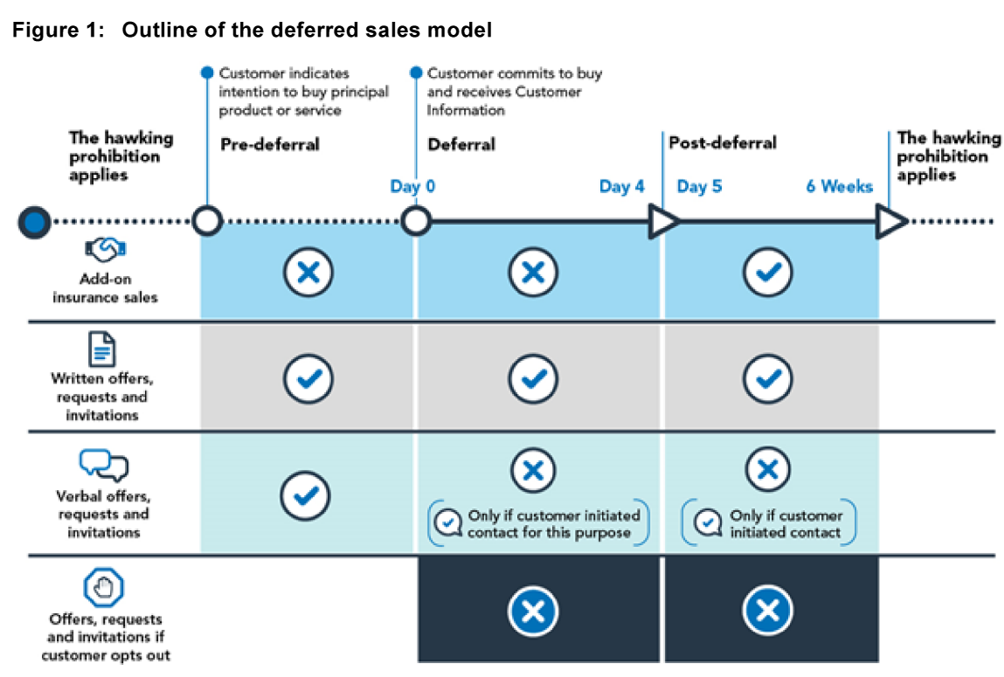

Customer Information Sheet (CIS)
The CIS can be provided electronically, but any “in person” sales of the Principal Product or Service requires the client to be given the option of receiving the document in hard copy at that time.
The legislation spells out the type and level of information that must be provided to a client in the CIS. This includes statements informing the client that:
- You can say no to being sold this insurance. It is not compulsory.
- Salespeople must wait 4 days before selling you insurance as an ‘extra’ to your main purchase.
- You can say ‘no’ to being contacted about the insurance.
- You can opt-out of being contacted about any insurance as an ‘extra’ to your main purchase.
- If you are unsure, consider your situation and ask yourself:
  - Do I need and understand this insurance?
  - Consider what the policy covers and what it excludes. You may already have other insurance or arrangements that will cover any potential loss or damage.
  - Could I get a better deal somewhere else?
  - Consider if another insurance product or company can better meet your needs. You may be able to shop around for a better deal.

What do we expect our staff and representatives to do?
Be aware and mindful of the Deferred Sales Model when looking at any opportunities to sell insurance products in conjunction with other products and services sold by third parties.

