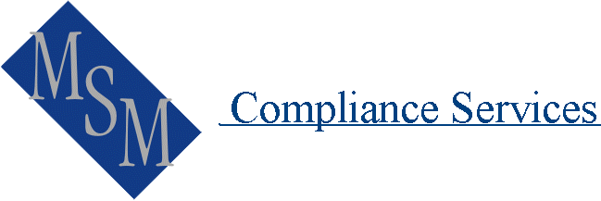 | Privacy Training Session Assessment Sheet

Name _________________________________________
No. | Statement | Answer
1 | The enhanced Privacy legislation takes effect from June 2014 | Yes No
2. | The Privacy legislation applies to both individuals and companies | Yes No
3. | From commencement of the enhancement legislation there will be 10 Australian Privacy Principals | Yes No
4. | The new legislation includes powers to fine and penalise businesses that breach privacy. | Yes No
5. | People are able to deal with us anonymously where practical and possible to do so. | Yes No
6. | FOS can apply sanctions and fines on members. | Yes No
7. | We can collect any information that we want to from clients, you never know when it might come in handy. | Yes No
8. | We can use client information for direct marketing but we must provide an Opt Out. | Yes No
9. | We can charge any fee we choose for any client requests for information regardless of what our costs are. | Yes No
10. | We do not need to worry about what other businesses around the world might do with information we provide them.. | Yes No
11. | We must make a copy of our Privacy Policy Statement available to clients free of charge. | Yes No
12 | We must correct information once we are aware it is incorrect. | Yes No
13 | Where we collect unsolicited information we must destroy it if it is not related to our Primary Purpose | Yes No
14 | Clients are unable to complain if we breach their privacy. | Yes No
15 | We only have to give clients access to information that we think they need to have. | Yes No

Score _______out of 15

